Analyzing and Visualizing Data

# Introduction

[WeRateDogs](https://en.wikipedia.org/wiki/WeRateDogs) is a popular twitter account that rates people's dogs with a humorous comment about the dog. We combined the WeRateDogs data with neural network image prediction from Udacity, and analyzed the dogs.

# Most popular dog breeds

According to the image prediction these are the most popular dog breeds in the account:

golden_retriever 139

Labrador_retriever 95

Pembroke 88

Chihuahua 79

pug 54

chow 41

Samoyed 40

Pomeranian 38

toy_poodle 38

malamute 29

15 percent of the dogs belongs to the three most popular breeds (if we accept the most probable image prediction breeds).

# And the winner is . . .

The name and the image of the most popular dog by retweets is unknown. Its retweet count is 84230.

Fortunately, the score winner is known. He is Atticus, and has a rating of 1776/10. Atticus is a real patriot.

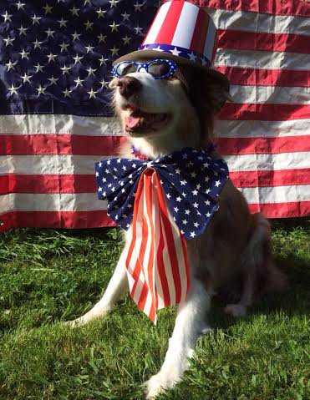

# Most popular words

I wanted to see the most popular words with real information. So I didn't consider personal pronouns, articles, conjunctions and other words needed to build a sentence. I wanted only words with contextual meaning. The most used words with contextual meaning are: meet (216), pet (174), pupper (161) and dog (138). 3 from the first 4 is a kind of "dog word".

# Dog Breed Counts

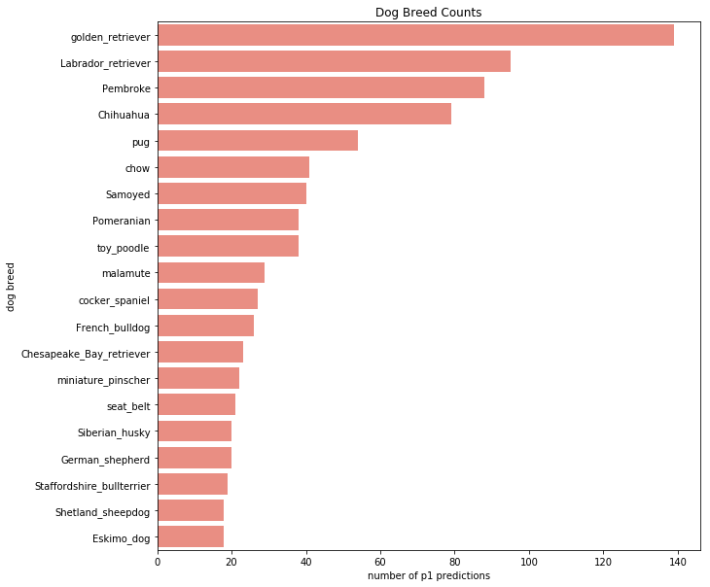

This plot shows the most popular dog breeds by occurrence according to the image predictions p1 (most probable) guess. It seems that the retrievers are the stars.

# Retweet count – favorite count scatterplot

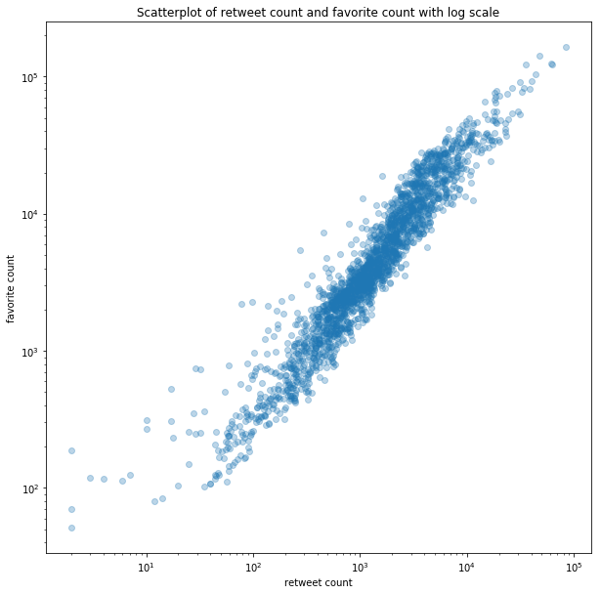

In the plot above we can see that as the larger the retweet count of a dog the larger the favorite count most of the time. This is what we would assume. The scatterplot uses log scales for the visualization.